WUSCEL-related homeobox gene family phylogeny

in crop species

**Minjeong Kang1**

**1**Interdepartmental Plant biology, Iowa State University, Ames, IA, USA

1. Introduction

The WUSCHEL-RELATED HOMEOBOX (WOX) gene family is one of the classes of plant homeobox proteins which involve in the important developmental processes, such as stem-cell maintenance and organ formation in shoot apical meristem (Alvarez et al., 2018). The WOX genes contain conserved homeodomain, which has 60 amino acid residues with the helix-loop-helix-turn-helix structure (Zhang et al., 2010). These WOX genes play important roles in *Arabidopsis* organizing center (OC) through the regulatory loop between CLAVATA (CLV) and WUSCHEL that involves the maintenance of the shoot apical meristem (Schoof et al., 2000).

The WOX protein family members can regulate cell differentiation of plant cell as both of activator and repressor (Zuo et al., 2002). The overexpressed maize WUS2 gene can dramatically improve the shoot regeneration of sorghum, rice, and sugarcane (Lowe et al., 2016). Also, none of the maize WUS orthologous expresses in *Arabidopsis*, and the CLV orthologue – WUS loop of grass differed from dicot plants (Nardmann and Werr, 2006). The previous research indicates that divergence of WOX genes among plant species may be related to the various differentiation pattern of the plant cell.

Phylogenetic analysis is the way to investigate the evolutionary development of organisms. Maximum likelihood (ML) is optimality criterion to select evolutionary trees. The likelihood (*L*) is defined as the probability of the data (*D*) given a model of evolution (*M*) and other parameters (*p*), such as model parameters and a tree topology (Posada et al., 2004).

*L* = P ( *D* | *M, p* )

The ML requires at least approximately correct model assumptions, such as GTR, the generalized time-reversible model (Tavaré, 1896), to derive a result. When the model is not enough to describe the evolution of the sequence, the ML may not guarantee good results (Allman and Rhodes, 2005).

In the present study, a total 46 WOX members from a turnip, tomato, potato, rice, maize, sorghum, *Arabidopsis* and green algae were analyzed by maximum likelihood method to investigate the divergence of WOX genes in modern crops.

1. Materials and Methods

*Search of WOX proteins and domain identification*

The sequence used in this paper were obtained from EnsemblPlants (https://plants.ensembl.org) and NCBI (https://www.ncbi.nlm.nih.gov). Total 44 WOX protein sequences from dicots: *Arabidopsis thaliana, Brassica rapa, Solanum lycopersicum,* and *Solanum tuberosum,* monocots: *Oryza sativa* (japonica group)*, Zea mays, and Sorghum bicolor* and green algae: *Ostreococcus lucimarinus* and *Ostreococcus tauri*. The WOX names used in this paper is based on the description in database and isoforms are marked as a and b (Supplementary Table 1). In order to examine the homeodomain of sequences, the motif analysis was carried out using MOTIF search (http://www.genome.jp/tools/motif/) and MAST (version 4.12.0) (Bailey and Gribskov, 1998).

*Multiple sequence alignment and Phylogenetic tree construction*

Multiple sequence alignments were conducted by using MAFFT (version 7.245) with auto strategy setting. Maximum likelihood analysis was conducted with the following parameters by RAxML (version 8.2.9): PROTGAMMAAUTO and bootstrap (100 replicates). The Dendroscope software (version 3.5.9) was used to visualize the tree.

1. Results

*Analysis of conserved domains*

The motif discovery was conducted to identify the conserved homeodomain in WOX family proteins. All protein sequences used for this study showed the characteristic homeodomain of WOX genes which is 60 aa helix-loop-helix-turn-helix structure (Figure 1 and Supplementary Table 2) (Lian et al., 2014).

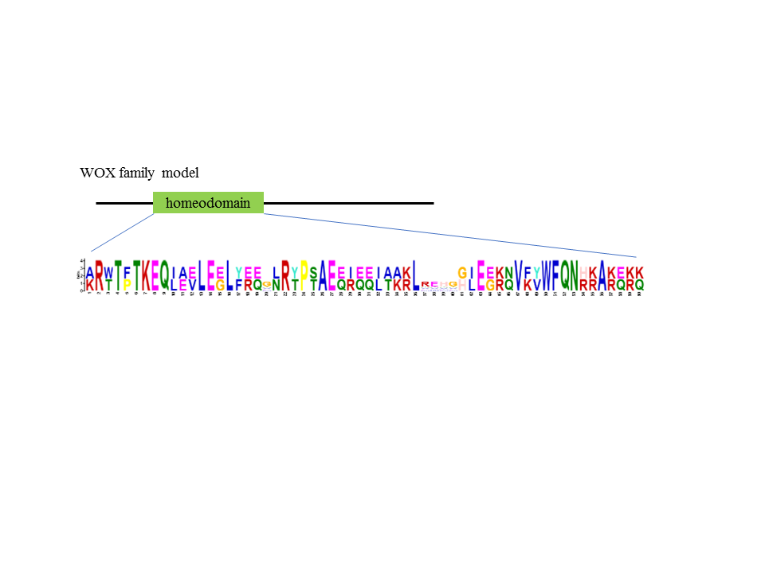

Figure 1. Conserved residues of WOX homeodomain sequence. The image was obtained by MAST (version 4.12.0).

*Phylogenetic analysis of WOXs*

Phylogenetic analysis was conducted to investigate the divergence of WOXs among crops. Figure 2 shows the ML tree with the bootstrap values. Phylogenetic tree of the WOX proteins have been divided into three clades: the WUS clade which specific to seed plants and ferns, the ancient clade which represents the earliest diverging WOX genes, and the intermediate clade which is interspersed between two clades (Graaff et al., 2009). Corresponded with the previous studies (Graaff et al., 2009; Lian et al., 2014), the WOXs were divided into three groups, designated WOX 1 - 7 and WUS in WUS clade, WOX 8, 9, 11, and 12 in intermediate clade, and WOX 10, 13 and 14 in ancient clade with high bootstrap value (Figure 2 and 3). However, the bootstrap values in interior edges of WUS clade is relatively lower than other clades. This result suggests that WUS clade contains more divergence members compared to other clades. Moreover, unlike other taxa, the OsWox7 and OsWox10 were found in the intermediate clade. Generally, each monocot and dicots formed subgroups in the clades. This result suggests that WOX gene divergence occurred before the speciation of monocot and eudicot.

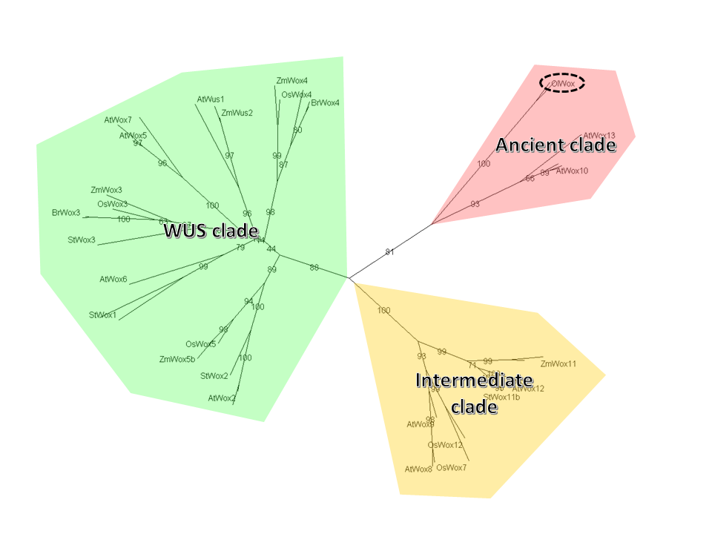

Figure 2. Phylogenic tree of WOX proteins. The tree contains three clades; WUS clade, ancient clade and intermediate clade. The black dotted circle indicates the green algae.

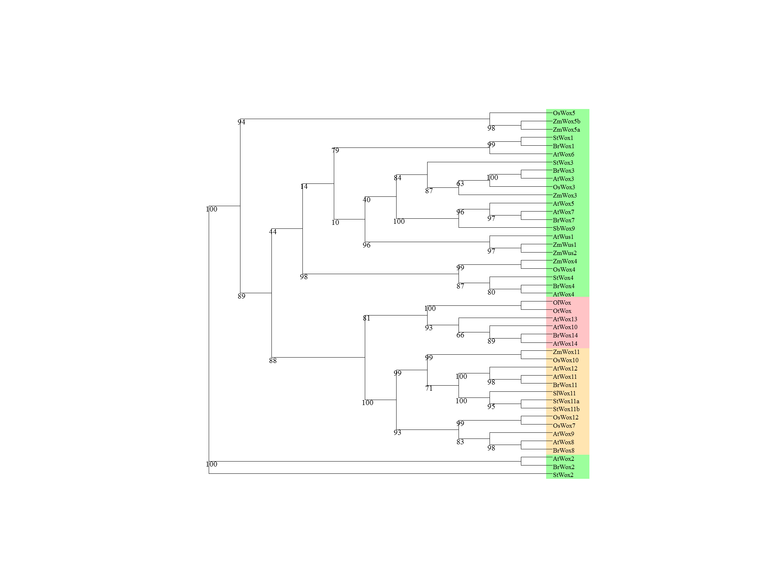

Figure 3. Unrooted phylogenetic tree of 46 WOX proteins with bootstrap value. The box color represents the clade of taxa. The green is the WUS clade, the red is ancient clade, and the orange is intermediate clade.

1. Discussion

In this study, most of WOX proteins formed clades with its homologs proteins and WOXs from green algae were included to the ancient clade. However, the OsWox7 and OsWox10 showed ectopic location. Previous research indicates that the WOXs from monocots form 3-5 clades unlike AtWOXs and maize WOX2 protein expression pattern is different from the WOX2 homologous protein of *Arabidopsis* (Nardmann and Werr, 2006; Nardmann et al., 2007; Lian et al., 2014). Therefore, it is possible that the differentiation of several WOXs may be occurred after speciation of monocot and dicot. To investigate its functional divergences, 3D structures of WOX protein is needed for the future study.

The crops important in agriculture field were analyzed to investigate the various differentiation pattern among the species. The result of the phylogenetic analysis is insufficient to explain the cell development patterns. It suggests that other factors such as cis-regulatory region or methylation may involve in the expression and function of WOX gene family.

**References**

Allman, E.S., and J.A. Rhodes. 2005. Lecture Notes: The Mathematics of Phylogenetics. : 126p.

Alvarez, J.M., N. Bueno, R.A. Cañas, C. Avila, F.M. Cánovas, and R.J. Ordás. 2018. Analysis of the WUSCHEL-RELATED HOMEOBOX gene family in Pinus pinaster: New insights into the gene family evolution. Plant Physiol. Biochem. 123(September 2017): 304–318.

Bailey, L.T., and M. Gribskov. 1998. Combining evidence using p-values: application to sequence homology searches. Bioinformatics 14(1): 48–54.

van der Graaff, E., T. Laux, and S.A. Rensing. 2009. The WUS homeobox-containing (WOX) protein family. Genome Biol. 10(12): 248.

Lian, G., Z. Ding, Q. Wang, D. Zhang, and J. Xu. 2014. Origins and evolution of WUSCHEL-related homeobox protein family in plant kingdom. Sci. World J. 2014(2009): 1–13.

Lowe, K., E. Wu, N. Wang, G. Hoerster, C. Hastings, M.-J. Cho, C. Scelonge, B. Lenderts, M. Chamberlin, J. Cushatt, L. Wang, L. Ryan, T. Khan, J. Chow-Yiu, W. Hua, M. Yu, J. Banh, Z. Bao, K. Brink, E. Igo, B. Rudrappa, P. Shamseer, W. Bruce, L. Newman, B. Shen, P. Zheng, D. Bidney, C. Falco, J. Register, Z.-Y. Zhao, D. Xu, T. Jones, and W. Gordon-Kamm. 2016. Morphogenic Regulators *Baby boom* and *Wuschel* Improve Monocot Transformation. Plant Cell 28(9): 1998–2015.

Nardmann, J., and W. Werr. 2006. The Shoot Stem Cell Niche in Angiosperms: Expression Patterns of WUS Orthologues in Rice and Maize Imply Major Modifications in the Course of Mono- and Dicot Evolution. Mol. Biol. Evol. 23(12): 2492–2504.

Nardmann, J., R. Zimmermann, D. Durantini, E. Kranz, and W. Werr. 2007. WOX gene phylogeny in poaceae: A comparative approach addressing leaf and embryo development. Mol. Biol. Evol. 24(11): 2474–2484.

Posada, D., T.R. Buckley, and J. Thorne. 2004. Model Selection and Model Averaging in Phylogenetics: Advantages of Akaike Information Criterion and Bayesian Approaches Over Likelihood Ratio Tests (J Thorne, Ed.). Syst. Biol. 53(5): 793–808.

Schoof, H., M. Lenhard, A. Haecker, K.F.. Mayer, G. Jürgens, and T. Laux. 2000. The Stem Cell Population of Arabidopsis Shoot Meristems Is Maintained by a Regulatory Loop between the CLAVATA and WUSCHEL Genes. Cell 100(6): 635–644.

Tavaré, S. 1896. Some Probabilistic and Statistical Problems in the Analysis of DNA Sequences. Am. Math. Soc. 17: 57–86.

Zhang, X., J. Zong, J. Liu, J. Yin, and D. Zhang. 2010. Genome-wide analysis of WOX gene family in rice, sorghum, maize, arabidopsis and poplar. J. Integr. Plant Biol. 52(11): 1016–1026.

Zuo, J., Q.-W. Niu, G. Frugis, and N.-H. Chua. 2002. The WUSCHEL gene promotes vegetative-to-embryonic transition in Arabidopsis. Plant J. 30(3): 349–359.

Supplementary Table 1. Accession numbers for all protein used in phylogenetic analysis

|  |  |  |
| --- | --- | --- |
| **Name** | **Accession number** | **Source** |
| AtWus1 | NP_565429 | https://www.ncbi.nlm.nih.gov/ |
| AtWox1 | AAP37133 | https://www.ncbi.nlm.nih.gov/ |
| AtWox2 | AAP37131 | https://www.ncbi.nlm.nih.gov/ |
| AtWox3 | AAP37135 | https://www.ncbi.nlm.nih.gov/ |
| AtWox4 | AAP37134 | https://www.ncbi.nlm.nih.gov/ |
| AtWox5 | AAP37136 | https://www.ncbi.nlm.nih.gov/ |
| AtWox6 | AAP37137 | https://www.ncbi.nlm.nih.gov/ |
| AtWox7 | NP_196196 | https://www.ncbi.nlm.nih.gov/ |
| AtWox8 | AAP37138 | https://www.ncbi.nlm.nih.gov/ |
| AtWox9 | AAP37139 | https://www.ncbi.nlm.nih.gov/ |
| AtWox10 | NP_173494 | https://www.ncbi.nlm.nih.gov/ |
| AtWox11 | NP_001118563 | https://www.ncbi.nlm.nih.gov/ |
| AtWox12 | AAP37141 | https://www.ncbi.nlm.nih.gov/ |
| AtWox13 | AAP37142 | https://www.ncbi.nlm.nih.gov/ |
| AtWox14 | NP_173493 | https://www.ncbi.nlm.nih.gov/ |
| BrWox1 | XP_009135563.1 | https://www.ncbi.nlm.nih.gov/ |
| BrWox2 | XP_009120441.1 | https://www.ncbi.nlm.nih.gov/ |
| BrWox3 | XP_009140922.1 | https://www.ncbi.nlm.nih.gov/ |
| BrWox4 | XP_009145045.1 | https://www.ncbi.nlm.nih.gov/ |
| BrWox7 | XP_009122174.1 | https://www.ncbi.nlm.nih.gov/ |
| BrWox8 | XP_009128835.1 | https://www.ncbi.nlm.nih.gov/ |
| BrWox11 | XP_009130381.1 | https://www.ncbi.nlm.nih.gov/ |
| BrWox14 | XP_009149550.1 | https://www.ncbi.nlm.nih.gov/ |
| OsWox3 | XM_015764119.1 | https://www.ncbi.nlm.nih.gov/ |
| OsWox4 | XP_015635367.1 | https://www.ncbi.nlm.nih.gov/ |
| OsWox5 | Q8LR86 | http://www.uniprot.org/uniprot/Q8LR86 |
| OsWox7 | Os01t0667400-01 | http://rapdb.dna.affrc.go.jp/ |
| OsWox10 | XM_015794156.1 | https://www.ncbi.nlm.nih.gov/ |
| OsWox12 | Os05t0564500-00 | http://rapdb.dna.affrc.go.jp/ |
| SbWox9 | XM_002458736 | https://www.ncbi.nlm.nih.gov/ |
| SlWox11 | XP_010322493.1 | https://www.ncbi.nlm.nih.gov/ |
| StWox1 | XP_006341531.1 | https://www.ncbi.nlm.nih.gov/ |
| StWox2 | XP_006350912.1 | https://www.ncbi.nlm.nih.gov/ |
| StWox3 | PGSC0003DMG400025358 | http://solanaceae.plantbiology.msu.edu/ |
| StWox4 | XP_006354857.1 | https://www.ncbi.nlm.nih.gov/ |
| StWox11a | XP_015164268.1 | https://www.ncbi.nlm.nih.gov/ |
| StWox11b | XP_006347326.1 | https://www.ncbi.nlm.nih.gov/ |
| ZmWus1 | CAJ84136 | https://www.ncbi.nlm.nih.gov/ |
| ZmWus2 | NP_001105961 | https://www.ncbi.nlm.nih.gov/ |
| ZmWox3 | CAM32346 | https://www.ncbi.nlm.nih.gov/ |
| ZmWox4 | CAM32347 | https://www.ncbi.nlm.nih.gov/ |
| ZmWox5a | CAM32348 | https://www.ncbi.nlm.nih.gov/ |
| ZmWox5b | NP_001306687 | https://www.ncbi.nlm.nih.gov/ |
| ZmWox11 | NP_001147238 | https://www.ncbi.nlm.nih.gov/ |
| OlWox | OSTLU_27102 | http://www.uniprot.org/uniprot/A4S6F9 |
| OtWox | XP_003082606.1 | https://www.ncbi.nlm.nih.gov/ |

Supplementary Table 2. Result of Motifinder

|  |  |  |
| --- | --- | --- |
| **Query** | **Pfam** | **Description** |
| AtWox1 | [Homeobox](http://www.genome.jp/dbget-bin/www_bget?pf:Homeobox) | PF00046, Homeobox domain |
| AtWox2 | [Homeobox](http://www.genome.jp/dbget-bin/www_bget?pf:Homeobox) | PF00046, Homeobox domain |
| AtWox3 | [Homeobox](http://www.genome.jp/dbget-bin/www_bget?pf:Homeobox) | PF00046, Homeobox domain |
| AtWox4 | [Homeobox](http://www.genome.jp/dbget-bin/www_bget?pf:Homeobox) | PF00046, Homeobox domain |
| AtWox5 | [Homeobox](http://www.genome.jp/dbget-bin/www_bget?pf:Homeobox) | PF00046, Homeobox domain |
| AtWox6 | [Homeobox](http://www.genome.jp/dbget-bin/www_bget?pf:Homeobox) | PF00046, Homeobox domain |
| AtWox7 | [Homeobox](http://www.genome.jp/dbget-bin/www_bget?pf:Homeobox) | PF00046, Homeobox domain |
| AtWox8 | [Homeobox](http://www.genome.jp/dbget-bin/www_bget?pf:Homeobox) | PF00046, Homeobox domain |
| AtWox9 | [Homeobox](http://www.genome.jp/dbget-bin/www_bget?pf:Homeobox) | PF00046, Homeobox domain |
| AtWox10 | [Homeobox](http://www.genome.jp/dbget-bin/www_bget?pf:Homeobox) | PF00046, Homeobox domain |
| AtWox11 | [Homeobox](http://www.genome.jp/dbget-bin/www_bget?pf:Homeobox) | PF00046, Homeobox domain |
| AtWox12 | [Homeobox](http://www.genome.jp/dbget-bin/www_bget?pf:Homeobox) | PF00046, Homeobox domain |
| AtWox13 | [Homeobox](http://www.genome.jp/dbget-bin/www_bget?pf:Homeobox) | PF00046, Homeobox domain |
| AtWox14 | [Homeobox](http://www.genome.jp/dbget-bin/www_bget?pf:Homeobox) | PF00046, Homeobox domain |
| AtWus1 | [Homeobox](http://www.genome.jp/dbget-bin/www_bget?pf:Homeobox) | PF00046, Homeobox domain |
| ZmWus1 | [Homeobox](http://www.genome.jp/dbget-bin/www_bget?pf:Homeobox) | PF00046, Homeobox domain |
| ZmWus2 | [Homeobox](http://www.genome.jp/dbget-bin/www_bget?pf:Homeobox) | PF00046, Homeobox domain |
| ZmWox5a | [Homeobox](http://www.genome.jp/dbget-bin/www_bget?pf:Homeobox) | PF00046, Homeobox domain |
| ZmWox5b | [Homeobox](http://www.genome.jp/dbget-bin/www_bget?pf:Homeobox) | PF00046, Homeobox domain |
| ZmWox3 | [Homeobox](http://www.genome.jp/dbget-bin/www_bget?pf:Homeobox) | PF00046, Homeobox domain |
| ZmWox4 | [Homeobox](http://www.genome.jp/dbget-bin/www_bget?pf:Homeobox) | PF00046, Homeobox domain |
| ZmWox11 | [Homeobox](http://www.genome.jp/dbget-bin/www_bget?pf:Homeobox) | PF00046, Homeobox domain |
| SbWox9 | [Homeobox](http://www.genome.jp/dbget-bin/www_bget?pf:Homeobox) | PF00046, Homeobox domain |
| SlWox11 | [Homeobox](http://www.genome.jp/dbget-bin/www_bget?pf:Homeobox) | PF00046, Homeobox domain |
| StWox4 | [Homeobox](http://www.genome.jp/dbget-bin/www_bget?pf:Homeobox) | PF00046, Homeobox domain |
| StWox2 | [Homeobox](http://www.genome.jp/dbget-bin/www_bget?pf:Homeobox) | PF00046, Homeobox domain |
| StWox1 | [Homeobox](http://www.genome.jp/dbget-bin/www_bget?pf:Homeobox) | PF00046, Homeobox domain |
| StWox11a | [Homeobox](http://www.genome.jp/dbget-bin/www_bget?pf:Homeobox) | PF00046, Homeobox domain |
| StWox11b | [Homeobox](http://www.genome.jp/dbget-bin/www_bget?pf:Homeobox) | PF00046, Homeobox domain |
| StWox3 | [Homeobox](http://www.genome.jp/dbget-bin/www_bget?pf:Homeobox) | PF00046, Homeobox domain |
| OsWox7 | [Homeobox](http://www.genome.jp/dbget-bin/www_bget?pf:Homeobox) | PF00046, Homeobox domain |
| OsWox12 | [Homeobox](http://www.genome.jp/dbget-bin/www_bget?pf:Homeobox) | PF00046, Homeobox domain |
| OsWox4 | [Homeobox](http://www.genome.jp/dbget-bin/www_bget?pf:Homeobox) | PF00046, Homeobox domain |
| OsWox5 | [Homeobox](http://www.genome.jp/dbget-bin/www_bget?pf:Homeobox) | PF00046, Homeobox domain |
| OsWox10 | [Homeobox](http://www.genome.jp/dbget-bin/www_bget?pf:Homeobox) | PF00046, Homeobox domain |
| OsWox3 | [Homeobox](http://www.genome.jp/dbget-bin/www_bget?pf:Homeobox) | PF00046, Homeobox domain |
| BrWox8 | [Homeobox](http://www.genome.jp/dbget-bin/www_bget?pf:Homeobox) | PF00046, Homeobox domain |
| BrWox14 | [Homeobox](http://www.genome.jp/dbget-bin/www_bget?pf:Homeobox) | PF00046, Homeobox domain |
| BrWox2 | [Homeobox](http://www.genome.jp/dbget-bin/www_bget?pf:Homeobox) | PF00046, Homeobox domain |
| BrWox7 | [Homeobox](http://www.genome.jp/dbget-bin/www_bget?pf:Homeobox) | PF00046, Homeobox domain |
| BrWox11 | [Homeobox](http://www.genome.jp/dbget-bin/www_bget?pf:Homeobox) | PF00046, Homeobox domain |
| BrWox4 | [Homeobox](http://www.genome.jp/dbget-bin/www_bget?pf:Homeobox) | PF00046, Homeobox domain |
| BrWox1 | [Homeobox](http://www.genome.jp/dbget-bin/www_bget?pf:Homeobox) | PF00046, Homeobox domain |
| BrWox3 | [Homeobox](http://www.genome.jp/dbget-bin/www_bget?pf:Homeobox) | PF00046, Homeobox domain |
| OlWox | [Homeobox](http://www.genome.jp/dbget-bin/www_bget?pf:Homeobox) | PF00046, Homeobox domain |
| OtWox | [Homeobox](http://www.genome.jp/dbget-bin/www_bget?pf:Homeobox) | PF00046, Homeobox domain |